# Validation Fixes

About Me.HTML Faults

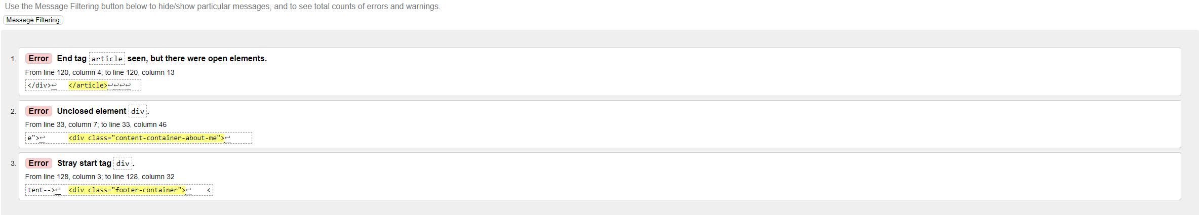

Added end div tag on line 120 and redesigned footer element in css and html and placed footer in body element as it was outside

Before: After:

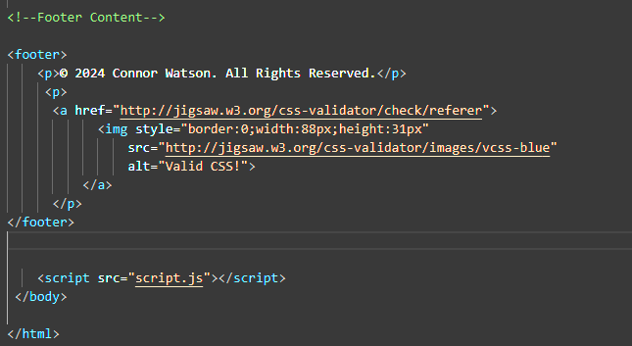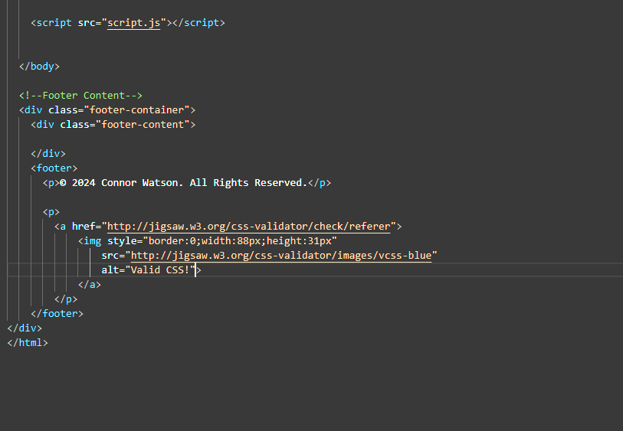

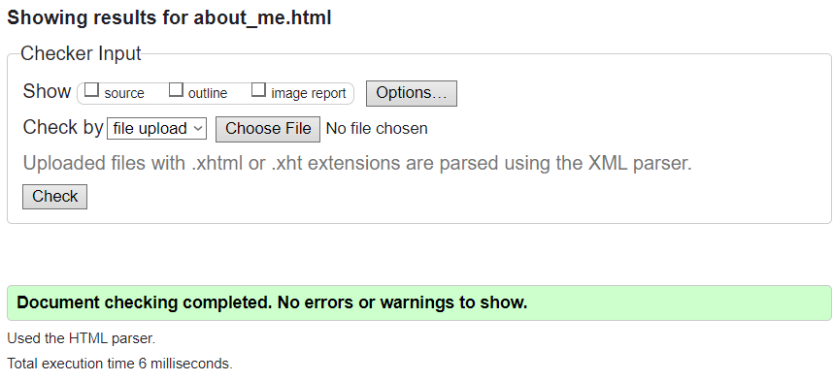No errors after code fixes

Contact Page.HTML Faults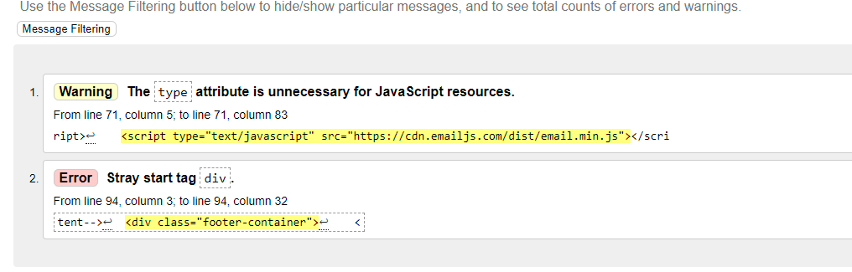

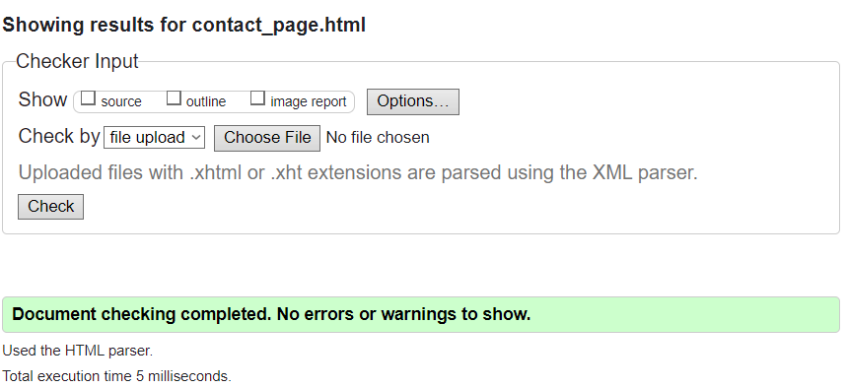Applied same fixes from about me html file to fix the stray div tag and removed the unnecessary java code

Index.HTML Faults

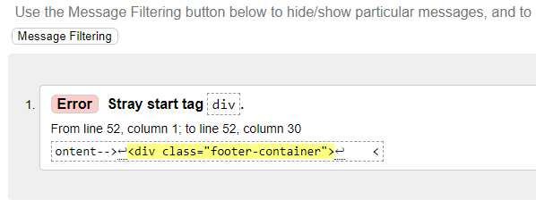

Applied same fix to other pages for stray div tag

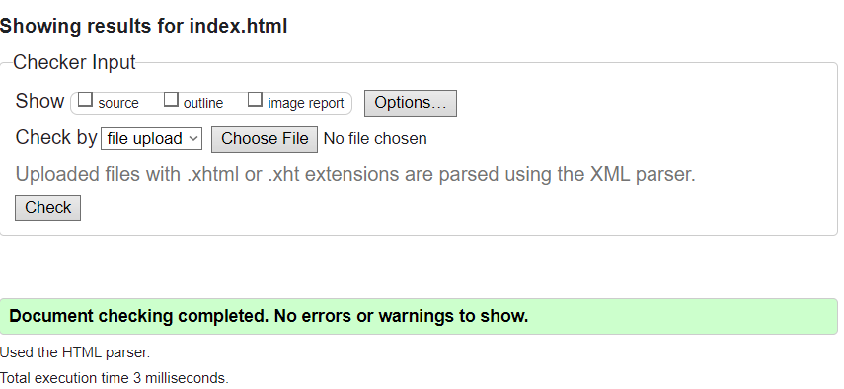

Personal Projects.HTML Faults

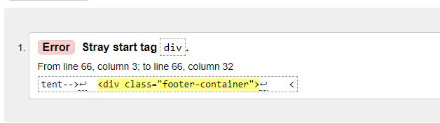

Again same problem and I applied the same fix 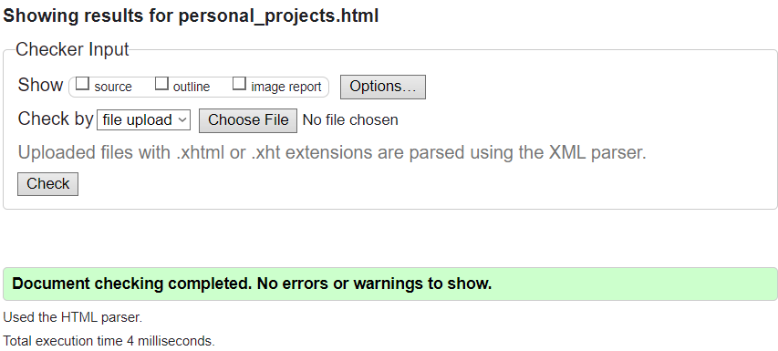

Style.css Faults

